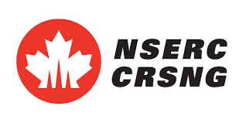
UFor Progress Report 2021
Submit progress report before February 15th 2022
To benoit.gendreau-berthiaume@uqo.ca
1 – Project progress

Provide a short description or your project progress since you have received your UFor scholarship (max 250 words).

2 – UFor internship information

Start date of internship:
End date of internship:
Time spent at host/partner institution:
Host/partner contact information:
Email of Host/partner contact information:

Provide a short description of your internship with a partner (either a completed internship or a detailed plan for an internship this winter or during the summer 2022 (max 250 words).

3 – Involvement in UFor activities
Provide a short description of your involvement in UFor activities since the start of your UFor scholarship (max 250 words).

4 – Research outputs and relevant urban forestry training

Provide a complete list of conference presentations, published articles, reports for partners and training completed since you received your UFor Scholarship.

5 – Other awards received

Provide a list of awards received other than your UFor scholarship since you joined the UFor network

5 – Activities you would like to see organised by UFor in the following year

Describe the type of activities you would like the UFor network to organise in the next year (max 250 words).

6 – Confirmation of Ufor scholarship renewal for 2022-2023

☐ I want to renew my Ufor scholarship for the period from September 2022 to August 2023
☐ I don't want to renew my Ufor scholarship for the period September 2022 to August 2023

Reason why I’m not renewing my scholarship:

